Analytical report:

Monitoring citations to EIGE from academia (January-March 2024)

**Prepared for**: EIGE

**Reference**: FWC EIGE/2024/OPER/03 Lot 2

**Date**: 15 January 2025



Contents

**1.** **Summary 4**

**2.** **Introduction 5**

**2.1.** Objectives 5

**2.2.** Methodology 5

**2.3.** Report structure 6

**2.4.** Report web application 6

**3.** **Analysis 7**

**3.1.** Number of mentions 7

**3.2.** EIGE’s outputs cited 8

**3.3.** Documents citing EIGE 11

**3.4.** Impact evaluation of documents citing EIGE 13

**4.** **Annex 1 – Quarterly report 16**

List of figures

Figure 1- Number of EIGE citations per article, January-March, 2024 8

Figure 2- Trends of EIGE’s output cited, January-March 2024 9

Figure 3- Type of EIGE output cited, January 2024 10

Figure 4- Type of EIGE output cited, February 2024 10

Figure 5- Type of EIGE output cited, March 2024 11

Figure 6- Trend of the type of EIGE’s output cited, January-March 2024 11

Figure 7- Breakdown of EIGE’s output cited, January-March 2024 12

Figure 8- Academic publications and journals citing EIGE, January-March 2024 13

Figure 9- Location of institutions that cited EIGE, January-March 2024 14

Figure 10- Impact evaluation of articles citing EIGE, January-March 2024 14

Figure 11- Weighted value of publications citing EIGE, January-March 2024 16

# Summary

On 24 September 2024, EIGE contracted Blomeyer & Sanz, in partnership with Policy Impact Lab, to conduct periodic impact monitoring reports and analysis corresponding to the period 2024. The Terms of Reference (ToR) refer to a general objective and five specific objectives:

* *General objective: To allow EIGE to better comprehend stakeholders’ use of EIGE data, evidence and outputs and thereby to produce more targeted outputs which fit better the needs of its stakeholders. To enable EIGE produce outputs which are used by its intended stakeholders.*
* *Specific objectives: To provide EIGE with information on (1) which EIGE outputs are cited in academia; (2) what are the main articles citing EIGE’s outputs; (2) what are the main research fields (topics) where citations to EIGE are found; (4) what is the importance of the citations identified; and (5) what is the trend observed in the citations to EIGE.*

This analytical report presents the **main findings** regarding the data on academia citing EIGE’s outputs during the period **January to March 2024**. The analytical report includes a statistical overview of the recorded references.

During the monitoring period (Q1 2024), the monitoring team has identified **15 citations to EIGE** from 10 documents. All the documents are **articles**.

The majority of citations have been published in **nine different** **EU-based journals** (except for one UK-based journal). Each article includes **one citation to EIGE**, except for two articles that each had three citations.

Regarding the authors of the articles citing EIGE, they are all different (**no repeated authors**) and belong to different research centres (almost all of them being **universities**).

**February** is the month with the **highest number of publications** (5). However, the difference with March (4) is insignificant.

The collected data allows for a (partial) **qualitative monitoring** of the citations. It is not possible to complete a comprehensive qualitative assessment, since the impact factor of the publishing journals for Q1 does not exist.[1] Only three publishing journals have a publicly available impact factor, but it is not possible to obtain any conclusion, as the three have different impact factors (with one scoring ‘average’, one ‘strong’, and one ‘very strong’).

Nevertheless, **most of the citations (6) are included in the main body of the article. All** the citations to EIGE are considered to be **positive.** Finally, when using ‘Altmetric’, it appears that there was a rather limited reference on social media to the documents citing EIGE’s output during the period corresponding to this monitoring.

# Introduction

1. This section introduces the report by briefly commenting on the objectives (Section 2.1), the methodology (2.2), and the structure of this report (2.3).

## Objectives

1. The monitoring team will provide two types of deliverables:

* **Quarterly monitoring reports**

The quarterly monitoring reports record all citations to EIGE and EIGE’s outputs from academia. The reports present the following information:

* Date of publication of the document citing EIGE;
* Name of the document citing EIGE;
* URL of the document citing EIGE;
* Name of the author/organisation citing EIGE;
* Name of the institutions where the authors work;
* Name of the journal citing EIGE;
* EIGE’s output cited;
* Type of EIGE’s output cited;
* Year of publication of EIGE’s output cited;
* Topic.

The quarterly data is recorded on an Excel spreadsheet and presented as an annex to this report.

* **Analytical reports**

The analytical report includes the main findings and trends for the monitoring period January-March 2024.

## Methodology

1. The report is based on the methodology agreed upon with EIGE on 12 December 2024. However, during the collection of data for the first quarterly report, we have identified several **caveats** (see point 8 below) that need to be taken into consideration for the current monitoring and analysis.
2. For the monthly reports, we have monitored the keyword “European Institute for Gender Equality” using the tool **Scite** and double checked the results using the tool Google Scholar.
3. We will only search for results in **English**.
4. To enable a more accurate list of results, we will search for the term **using “…”**. Not using “…” produces an extremely high number of wrong and partial results. We propose not to search for the term “EIGE”, as the search leads to numerous false results (such as EIG, or the German term ‘eigen’).
5. For the analytical report, we have produced graphs and trends only based on the data collected for the current quarter (Q1).
6. **Caveats**:

* When using the agreed search tools (Scite, Google Scholar), it is not possible to identify the documents by the exact **date** (only by year).
* When using the agreed search tools, it is not possible to access and read all the documents. Therefore, it is not always possible to identify the precise EIGE **output** that the document is referring to.
* For the same reason mentioned above, it is not possible to access all documents and therefore to identify the main **topics** where citations to EIGE are found.
* As this is the first monitoring completed for 2024, it is not yet possible to observe the **trends** concerning citations to EIGE.

## Report structure

1. The report is organised in two main sections and three annexes, namely:

* This Introduction (section 2), including detail on the objectives, methodology and report structure.
* The Analysis (section 3), presenting the analysis of the quarterly reports.
* Annex 1 presents the Excel file that contains all the citations (January-March 2024).

## Report web application

1. In addition to the text version, the report is also available as a web application. The application is written using Python and is hosted on the Streamlit platform. In the web application, users can access all previous quarterly reports, interact with some of the visualisations, and download the report data. Additionally, the app version is mobile-friendly and can be viewed from both a personal computer and a smartphone. The web application is available at <https://citation-monitoring.streamlit.app/>.

# Analysis

1. This section presents the findings and analysis of the quarterly reports (January-March 2024).
2. The presentation is organised as follows:
   * Number of mentions to EIGE (3.1);
   * EIGE’s output that has been referenced (3.2);
   * Documents that have referenced EIGE (3.3).

## Number of mentions

1. In general, the number of mentions to EIGE (15) by academia seems limited when compared to the number of mentions to EIGE made by other institutions.[2] However, due to the nature of the academic publications, the ‘rhythm’ of publishing in general is considerably slower, and it is not possible to compare them with other types of publications that do not have such a lengthy and controlled procedure.
2. The 15 citations identified correspond to 10 different articles, which means that most of them only include one citation to EIGE or EIGE’s outputs.

Figure 1- Number of EIGE citations per article, January-March, 2024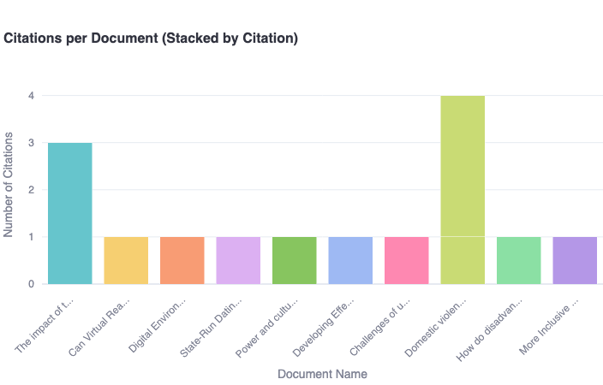

## EIGE’s outputs cited

1. The academic articles identified refer to five different EIGE outputs (reports, gender equality index, thesaurus, gender statistics database, Beijing Platform of Action (BPfA)), with the reports being the type of output used most frequently (7).
2. Regarding the reports cited, it is worth noting (a) there are no repeated reports cited and (b) the dates of the reports correspond to the past 10 years.
3. Since this monitoring (Q1) is the first one completed for this monitoring assignment, the monitoring team has no previous data to compare with or to allow for the production of trends.

Figure 2- Trends of EIGE’s output cited, January-March 2024A graph with colored lines and text

Description automatically generated

### Monthly data

1. The following figures present the types of EIGE output mentioned in the period January-March 2024.
2. In January 2024, we identified two citations that include EIGE’s outputs: one mention of a report, and one mention of the gender equality index.

Figure 3- Type of EIGE output cited, January 2024A blue and yellow squares

Description automatically generated

Figure 4- Type of EIGE output cited, February 2024

1. February was the most active month, with 5 publications citing various EIGE’s outputs, including reports, BfPA, and thesaurus.
2. In March, EIGE’s cited output included 2 reports, gender equality index, and gender statistics database.

Figure 5- Type of EIGE output cited, March 2024A graph of different colored squares

Description automatically generated

Figure 6- Trend of the type of EIGE’s output cited, January-March 2024A graph of different colored squares

Description automatically generated

1. Overall, reports (6) were the most commonly cited type of EIGE’s outputs in January-March 2024, followed by gender equality index (2).

Figure 7- Breakdown of EIGE’s output cited, January-March 2024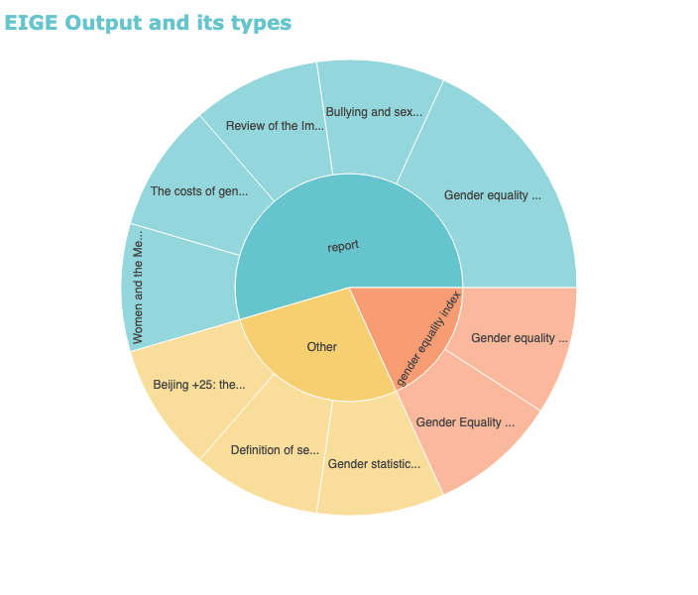

1. The sunburst chart in Figure 7 breaks down each output category into specific outputs. The interactive version of this chart is available at <https://citation-monitoring.streamlit.app/Q1_2024_Report>.

## Documents citing EIGE

1. Due to the nature of the academic publications monitored, it is not surprising to find that these types of documents are all research articles, with the exception of one report. No books or monographs have been identified for Q1.
2. The academic publications have been prepared by 34 different authors. Most of the publications belong to researchers from different universities in the EU, except for one research institution in Mexico and one in the United Kingdom. There are no repeated authors or universities.
3. The articles citing EIGE have been published in 9 different journals, most of them from the EU (7).

Figure 8- Academic publications and journals citing EIGE, January-March 2024

| **Name of the article** | **Name of the journal** | **Universities** |
| --- | --- | --- |
| The impact of the COVID-19 pandemic on part-time jobs and the issue of gender equality | Quality-Access to Success | University of Bratislava |
| Can Virtual Reality be Used for the Prevention of Peer Sexual Harassment in Adolescence? First Evaluation of the Virtual-PRO Program | Psychological Intervention | University of Sevilla |
| Digital Environments of Education 4.0 and complex thinking: Communicative Literacy to close the digital gender gap | Journal of Interactive Media Education | Institute for the Future of Education, Mexico |
| State-Run Dating Apps: Are They Morally Desirable? | Philosophy and Technology | Ghent University |
| Power and culture: Understanding EU policies on agriculture and gender equality | Sociologia Ruralis | Newcastle University |
| Developing Effective Interventions for Gender Equality in UK Construction Project Organisations | APM Research Fund Series | Association for Project Management |
| Challenges of using specialist domestic and sexual violence and abuse service data to inform policy and practice on violence reduction in the UK | Journal of Gender-Based Violence | University of Bristol, City University of London, King's College London |
| Domestic violence and social services in Latvia, Lithuania, Slovakia, and Nigeria: Comparative study | SHS Web of Conferences | Iscte-University Institute of Lisbon, Riga Stradiņš University, Catholic University in Ružomberok, Mykolas Romeris University, Adekunle Ajasin University |
| How do disadvantaged groups perceive allies? Women's perceptions of men who confront sexism in an egalitarian or paternalistic way | European Journal of Social Psychology | University of Granada, JagiellonianUniversity, James Cook University, University of Osnabrück, Western Sydney University |
| More Inclusive and Wider Sources: A Comparative Analysis of Data and Political Journalists on Twitter (Now X) in Germany | Journalism and Media | Technical University of Munich |

Figure 9- Location of institutions that cited EIGE, January-March 2024A map of the world with red dots

Description automatically generated

## Impact evaluation of documents citing EIGE

1. In addition to quantitative analysis of EIGE citation monitoring, quarterly and yearly reports also include a qualitative analysis that aims to assess the importance and impact of citations. Impact evaluation consists of four principal metrics: number of citations of a particular article, impact factor of a journal an article is published in, and sentiment of the citation, and location of the citation in an article.

Figure 10- Impact evaluation of articles citing EIGE, January-March 2024

1. Overall, the **sentiment of all citations** in Q1 2024 was evaluated as positive. Furthermore, the majority of citations were located in the body of the article, rather than just in the abstract or references. The number of times the articles mentioning EIGE were cited in other academic publications was rather limited - the most cited articles (“The impact of the COVID-19 pandemic on part-time jobs and the issue of gender equality” and “Domestic violence and social services in Latvia, Lithuania, Slovakia, and Nigeria: Comparative study”) were each cited 3 times. However, it is important to note that academic publications often gain more traction with time.
2. For Q1, it is not possible to assess the **impact factor of the journals** that include citations to EIGE, as most of them have not been recorded on the tool that is used for allocating the impact factor, i.e. Scopus. There are only three journals where the impact factor is publicly available, and they show three different impact factors of ‘average’ (1), ‘strong’ (1), and ‘very strong’ (1).
3. Regarding the use of the citations to EIGE on **social media,** we have observed that the social media platform most frequently used for citing EIGE’s outputs is X (formerly known as Twitter), with a total of 32 posts by X users.

### Impact ranking

1. While the impact metrics described above provide us with a micro view on the academic and social impact of the articles citing EIGE, it does not allow us to conduct a less granular analysis. To ensure comparability between the articles, we attributed a weight to each metric: 0,3 for number of citations, 0,2 for the impact factor and the altmetric, and 0,15 for location and category of the citation.

Figure 11- Weighted value of publications citing EIGE, January-March 2024

| impact factor of the journal: 1 respectable; 2 strong; 3 very strong (using free version of scopus) | number of citations (using google scholar) | location of the citation: 3 body of the article; 2 introduction; 1 bibliography/reference | category of mention: 1 positive; 0 neutral; -1 negative | number of mentions in social media using altmetric | ranking/weight |
| --- | --- | --- | --- | --- | --- |
| 1 | 3 | 3 | 1 |  | 2,1 |
|  | 1 | 2 | 1 | 3 | 1,15 |
|  | 1 | 2 | 1 | 0 | 1,15 |
|  | 1 | 3 | 1 |  | 1,3 |
|  | 1 | 1 | 1 | 4 | 1 |
|  | 1 | 2 | 1 | 0 | 1,15 |
|  | 1 | 2 | 1 | 12 | 1,15 |
|  | 1 | 3 | 1 | 0 | 1,3 |
|  | 3 | 3 | 1 | 0 | 1,9 |
| 3 | 1 | 3 | 1 | 8 | 1,9 |
| 2 | 1 | 3 | 1 | 5 | 1,7 |

1. These rankings will serve as a baseline and will be used for trend comparison in future reports, as the monitoring team collects more data.

# Annex 1 – Quarterly report

Annex 1 presents the data recorded for Q1 in a separate Excel file.

1. This means that Scopus has no publicly available information on the impact factor of the publishing sources.
2. This assessment is based on the experience of the monitoring team from their previous assessment of monitoring citations to EIGE made by EU institutions and social partners between 2019 and 2023.